**Model Development Phase Template**

|  |  |
| --- | --- |
| Date | 15 Nov 2024 |
| Team ID | 739938 |
| Project Title | AI Enabled Candidate Resume Screening |
| Maximum Marks | 10 Marks |

**Initial Model Training Code, Model Validation and Evaluation Report**

The initial model training code for AI Enabled Candidate Resume Screening will be shared through a future screenshot, showcasing the process of text preprocessing, vectorization, and training logistic regression models. The model uses natural language processing and machine learning techniques to analyze resume content and predict candidate suitability. The model validation and evaluation report will summarize the performance of multiple models, including their accuracy, precision, recall, F1 score with the details presented via respective screenshots.

**Initial Model Training Code (5 marks):**

Paste the screenshot of the model training code

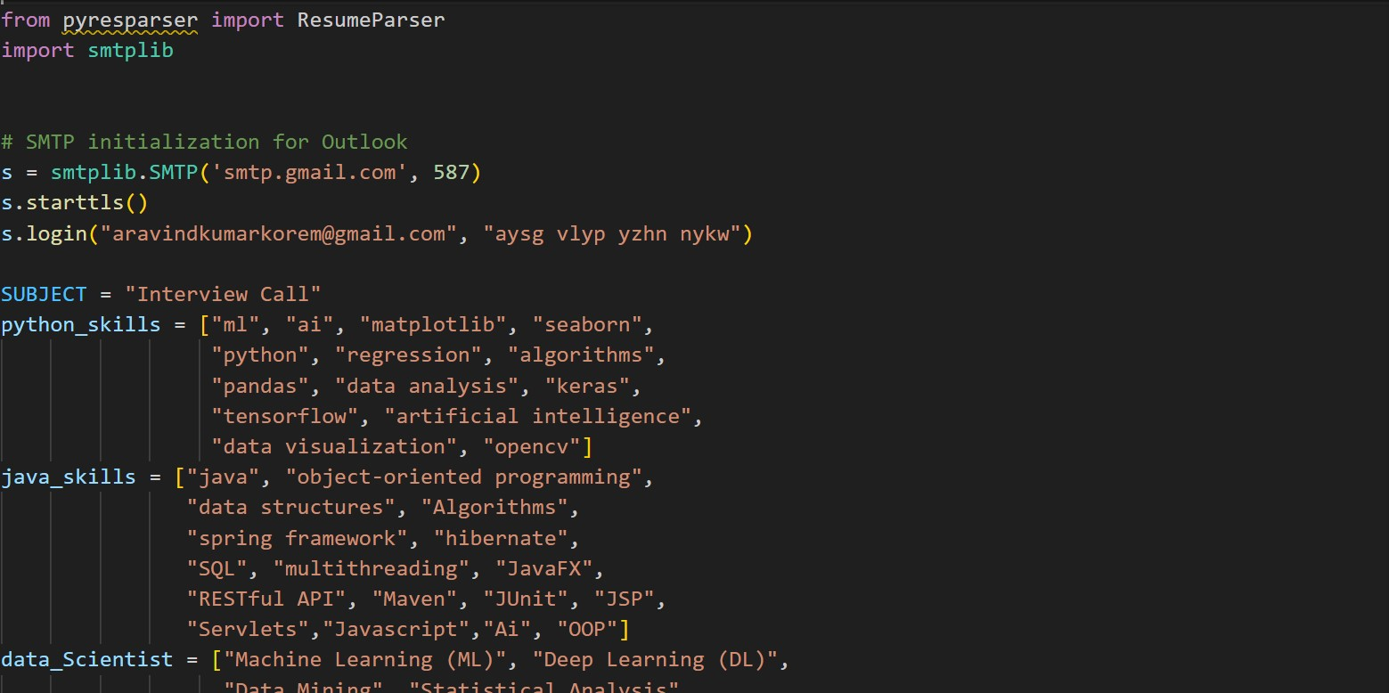

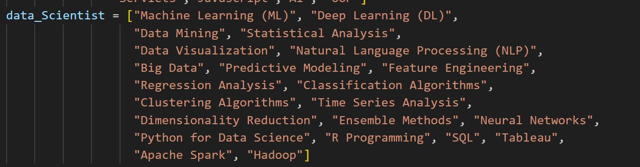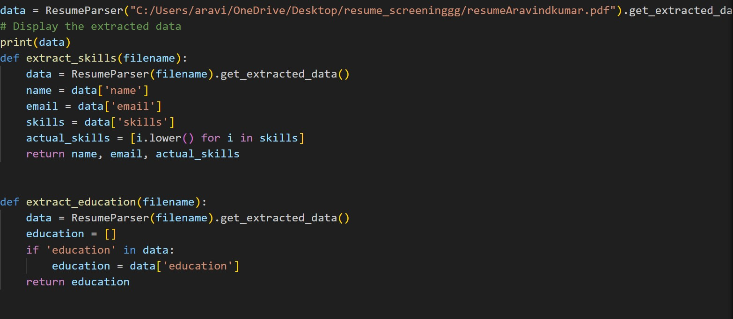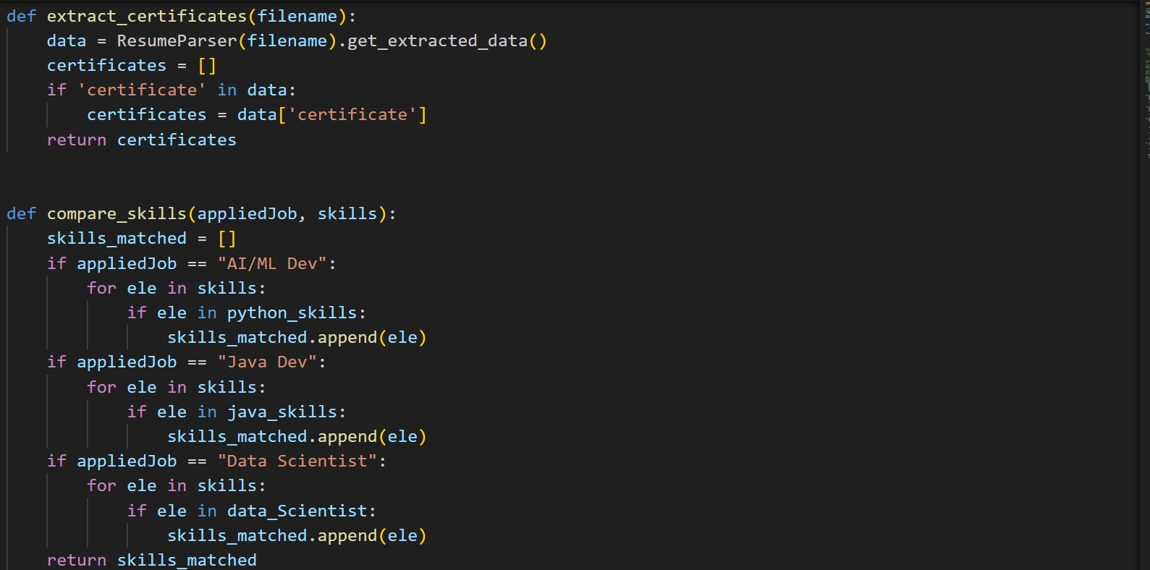

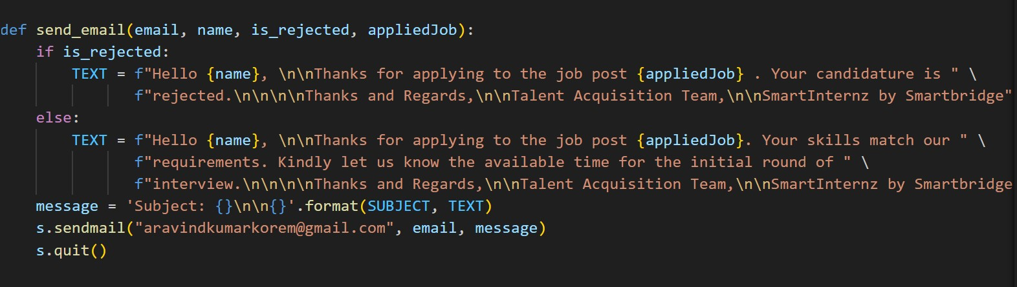

**Model Validation and Evaluation Report (5 marks):**

|  |  |  |
| --- | --- | --- |
| **Model** | **Summary** | **Training and Validation Performance**  **Metrics** |
| Model 1 | Spacy is a powerful, open-source library designed for advanced natural language processing (NLP) in Python. It was developed by Matthew Honnibal and Ines Montani, and first released in 2015. Unlike other NLP libraries such as NLTK, which are often used for educational purposes, spaCy focuses on providing tools suitable for production environments, making it ideal for building applications that require efficient text processing and understanding. |  |
|  |  |  |
|  |  |  |